Senario:

Input Command : git – version

Output : 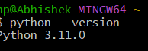

I am using git terminal in git if I want to know the version command

Section A

1.

Man ls is used to make the list when I rus ls command in git bash terminal. This list is visible.

Output:

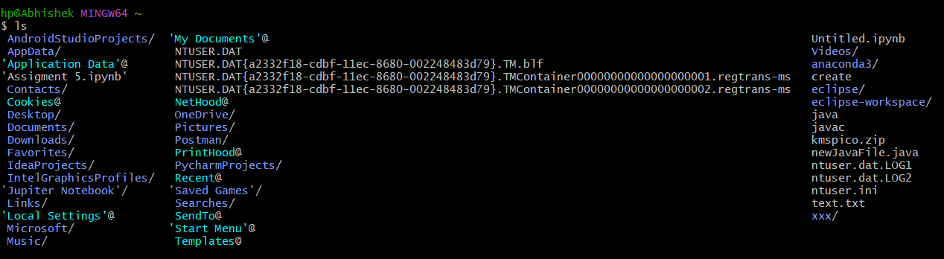

2.

When I run help command on git bash these following output are visible.

Output:

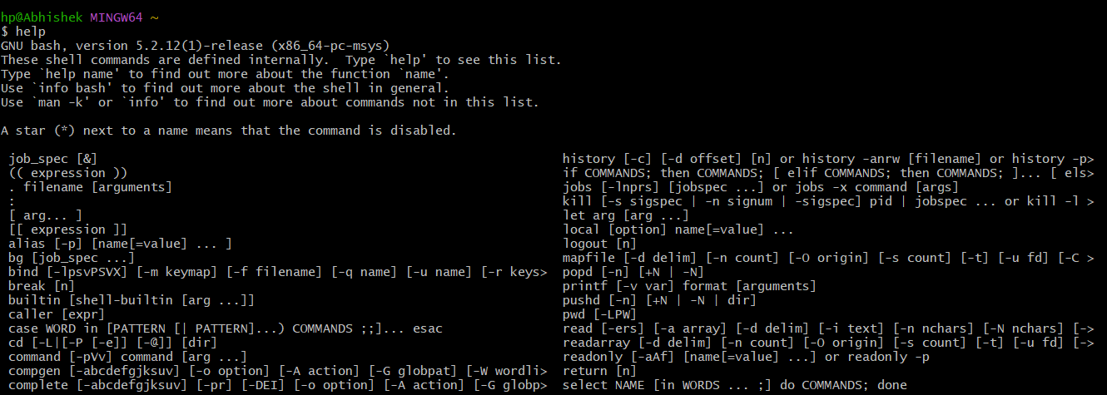

3.

When I run version command git bash following output are visible..

Output: 

Section B

Part 1|Level Easy

When I run cpu getinfo on gitbash following output are visible.

Output:



When I run memory getinfo on git bash following output are visible.

Output:



Part 2| Level Intermidiate

When I run new user on git basg following output are visible.

Output:



When I run user list command on git bash following output are visible.

Output:



When I run all the users with sudo permissions on git bash following output are visible.

Output:



Part 3 | Advanced Level

When I run file get info on git bash I get the following output.

Output: 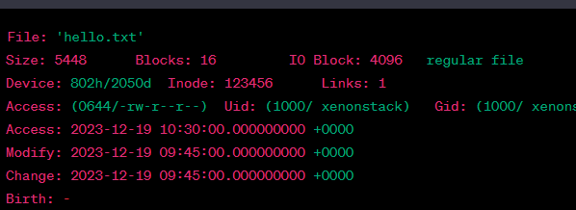

When I run file getinfo [options] command on git bash following output are visible

Output:

